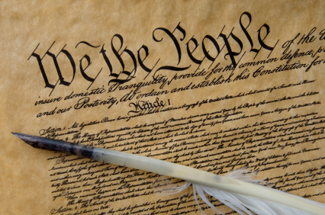
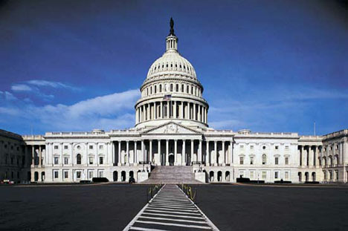

Constitution Exploration!

Your job is to explore the Constitution and discover how our
government works, and how the Constitution affects us today.

There are three parts to this project. You and your partner will create a powerpoint presentation to present the information from your research. It must include a minimum of 10 slides.

Who Makes Up Our Government?
1) identify the 3 branches of government, and the responsibilities (jobs) of each branch (put all information on the graphic organizer slide)
2) describe the requirements for becoming a member of each branch

Use the following links: Branches of Government
House of Representatives
Senate

Town Hall Meeting
You and your partner will select a topic of your choice from a list of current “hot topics” that have come up for debate in recent years. You and your partner must:
1) Choose a topic that interests you both. Read the poster.
2) Choose a side, and type a paragraph defending it IN YOUR OWN WORDS (you can use their ideas as a guide).
3) In your paragraph, explain which branch(es) of government is/are affected by the issue you chose.

Use the following links: Town Hall Walls Posters
The Constitution Center - "Explore Topics"

Extra! Extra!
You and your partner will choose a current news article that relates to the Constitution. You must: 1) Copy and paste the title of the article onto a slide
2) Read the article, and type a paragraph explaining what the article is about. In the paragraph, list the branches of government the article’s topic deals with.

Use the following links: Constitution News Wire
The Constitution Center - "Explore Topics"

